Fife Mountaineering Club Newsletter March 2024

The activities of the first two months of this year seem to have been very similar to the first two months of 2023! Just as last year when the forecasts or other commitments of members on 2nd January led to a decision not to walk out to Barry Buddon and then light a fire and cook our dinner, again this year a dodgy forecast led to a similar decision. Again we settled for a walk from Tayport out to Tentsmuir Point then turning South along the beach before turning into the forest for part of our return. It is an area that most of us have known for most of our lives and despite being there a year ago, which had been a full year since Storm Arwen, we were all amazed at how much more it has changed since our visit a year ago Huge areas of trees have been felled in the clear up following the various storms over the previous two years but we still had to climb over a large fallen tree blocking our path!
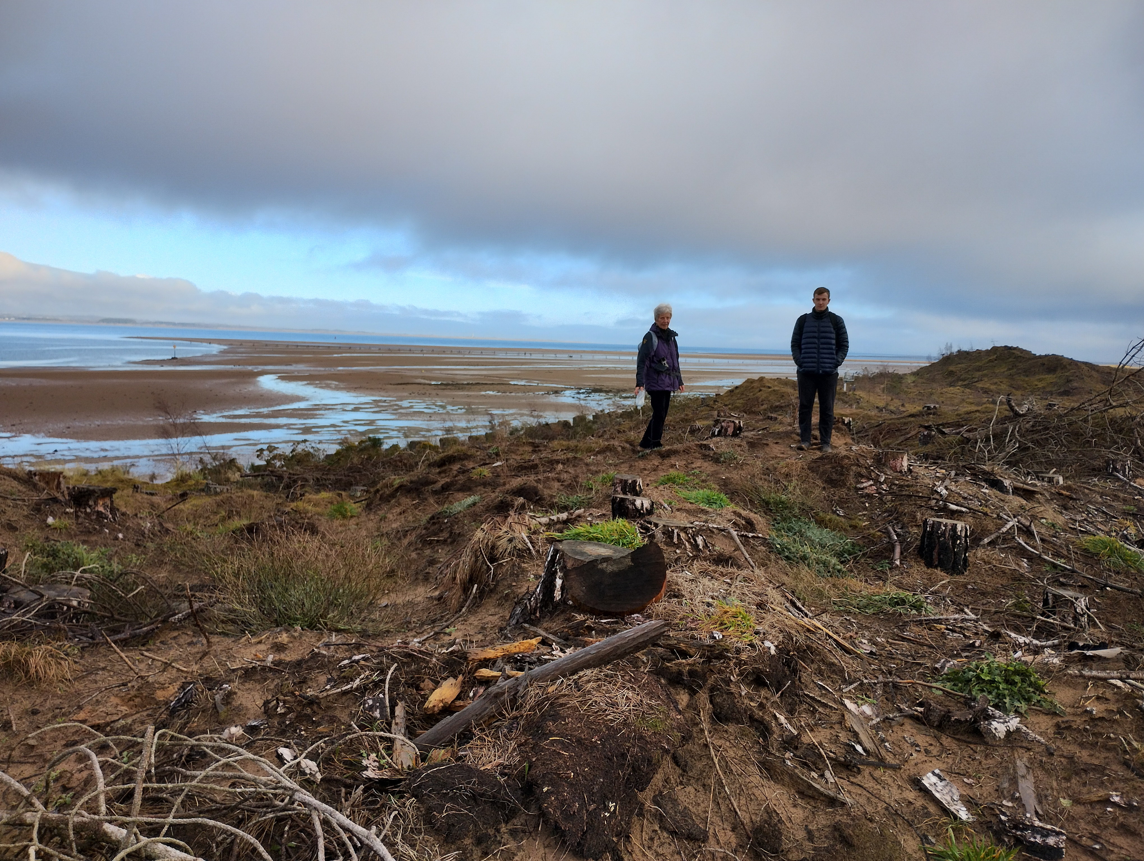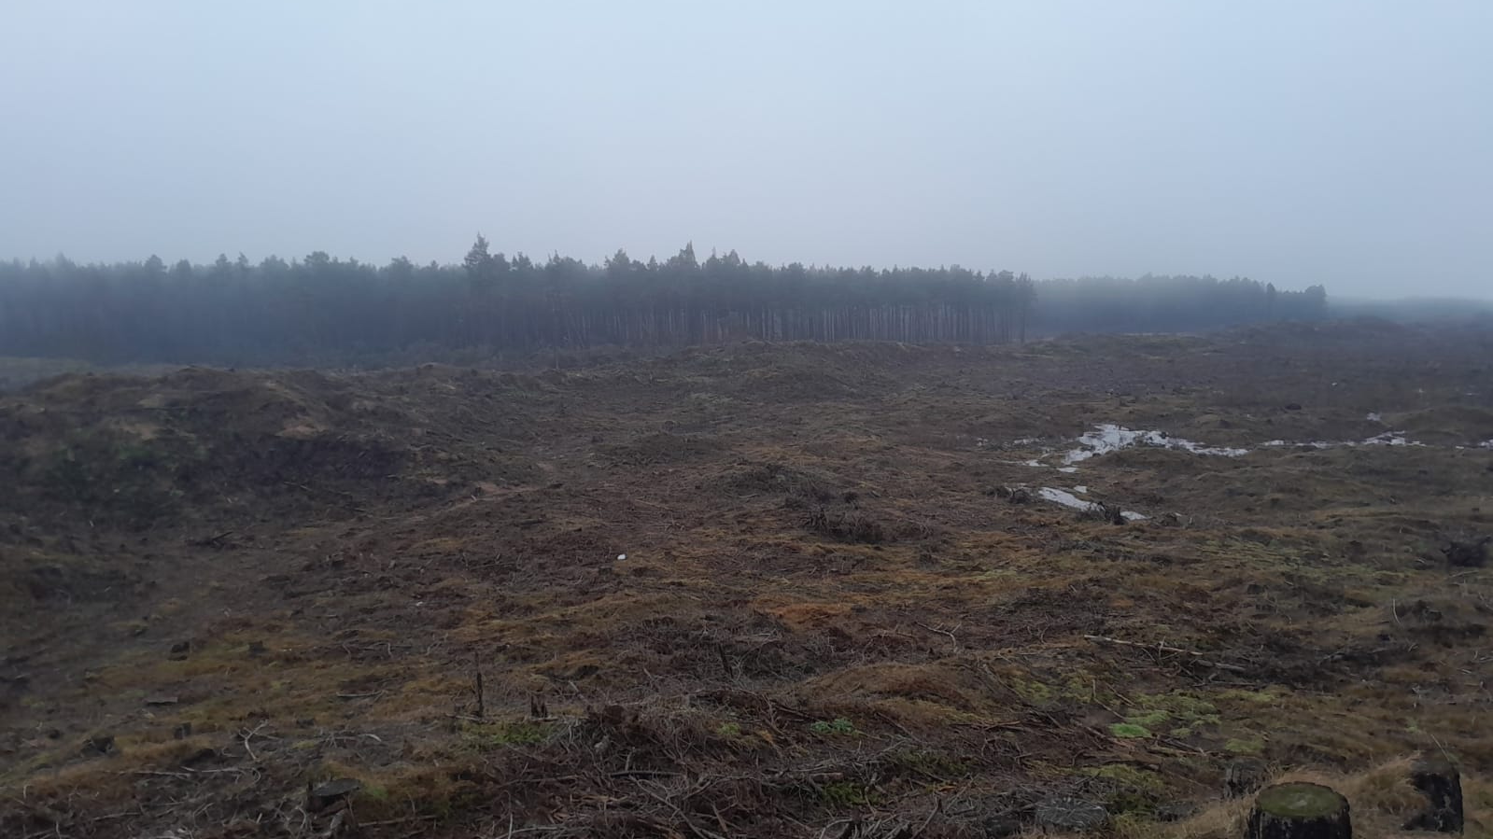
Then just as last year, for the next outing in February the group’s starting point was the Glen Sherup Car Park in Glen Devon. From there they chose a quite different route from last year and completed the horseshoe of the 2,000ft tops of Innerdownie, Whitewisp and Tarmangie Hills.
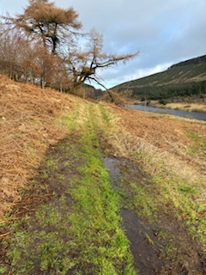 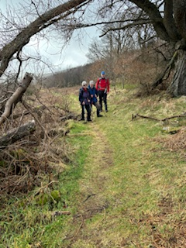 Glen Sherup walk
The next Meet was very well attended when in early March fifteen of us met for a meal at “The Courtyard” in Cupar! The last time the Club had had a meal out in a Fife restaurant was pre Covid. Both the food and the service at the Courtyard were excellent and I think we all went home thinking that this was something that should go back on the normal annual programme of Club events.
Since the dinner three of us represented the Club as a team and took part in the annual Mountain Mind Quiz. The usual Clubs which enter are those from Tayside and NE Fife. This year’s quiz took place in Blairgowrie which understandably had deterred some of our Fife based members from turning out on a Tuesday evening and that combined with us being a very small Club meant we didn’t expect to do especially well but we went home feeling we had achieved a respectable score and we were well clear of being awarded the Booby prize of the old boot! We all enjoyed our evening in Blairgowrie Golf Club which was a great venue.
The AGM was held on 17th January on Zoom, once again taking advantage of Morag’s Zoom account and her willingness to host it, allowing those such as Vivien based in distant Devon to join us and Zoom cetainly suits those of us, including myself, who do not enjoy the drive to and from St Andrews on a January evening. The meeting’s formal business was straightforward with the committee remaining unchanged and there also being no change in the subscription levels. These remain, due to the Club’s current healthy bank balance, at £25 for full membership of which £21.75 for each member will be paid to Mountaineering Scotland (MS) to cover the Club’s affiliation fee from April 2024 – March 2025 which covers liability insurance for any Club related activity. It also includes the cost of The Scottish Mountaineer (the MS magazine) which goes to every paid up Club member. Those who are members of more than one Club and whose £21.75 is being paid to MS by their other Club need only pay £7 for their FMC membership and for those just wanting to keep in touch and whose membership is purely social the membership fee is £5. Your subscriptions are now due so please, if you wish to remain a member, could you, if you haven’t already done so, pay Irene, our treasurer, either by cheque made out to “Fife Mountaineering Club” or by doing a bank transfer into the Club account of the appropriate sum but please name it so that Irene knows who it is from. Let me know if you require the bank details. The business meeting was then followed by the usual quiz which as usual was prepared by last year’s winner who was Catherine and it turned out that it was me by a narrow margin who was the winner so I will have to devise a quiz for next year!
Looking ahead the usual cottage at Boat of Garten has been offered to us for the last weekend of April (26th – 28th). So far there are 6 of us who have indicated they would definitely like to go and there is also a possible 7th who has expressed interest, There is plenty of space for several more so if anyone else is interested please let me know.
Usually the Club Summer week has been either to the far NW such as the week to Reiff last year or to a Scottish Island with hills, such as Skye, Harris, Rum, Arran or Mull. This year there was a request from some of the Club veterans who are chasing Grahams to go to the Cowal peninsular somewhere near Dunoon as there are a significant number of Grahams in that area and it is too far to go for a day trip from Fife or Dundee. I have therefore booked a self catering house in Blairmore, overlooking Loch Long for the week 15th – 22nd June. There are 6 of us already committed to going but the house sleeps 8. There is therefore potentially space for two more but realistically just one, unless a couple wish to go as the extra space is a double bed! Let me know if you are interested in going for either the whole week or even just part of the week.

Recent months have been so wet with the occasional fine days rarely happening on a Sunday and I think this is the reason why a number of potential outings have ended up being cancelled. Some of us have lost our enthusiasm for days on the hills when the forecast is just for rain very often combined with strong winds as well. Hopefully as the daylight hours get longer there will be an improvement significant enough to tempt more of us out. Jean

